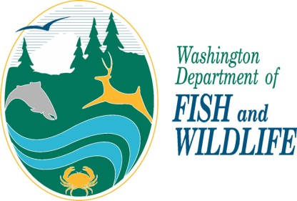 | Personal information provided to the Washington Department of Fish and Wildlife may be disclosed via a public records request. All the information you provide in this application form becomes a public record that may be subject to inspection and copying by members of the public, unless an exemption in law exists. The Department’s policy regarding Privacy Protection and Public Disclosure Requests is available upon request.
Falconry Application

Transfer Applicants Only: From what state are you transferring? ___________________________________
What is your Permit Class and Permit #:
Have you been a Washington State resident for at least 90 days? Yes No
WA State Driver’s License #:

You must enclose a copy of your State’s Falconry Permit with this application. If you are transferring as an
Apprentice you must obtain a Washington State General or Master falconer Sponsor.

ALL APPLICANTS

Name: Male Female

Date of Birth: Occupation:

Hair: Eyes: Height: Weight:

Contact and Facility Information

Home Phone: Work Phone: Cell Phone:

Email address:

MAILING ADDRESS: City: Zip Code:

FACILITY ADDRESS: City: Zip Code:

HOME ADDRESS: City: Zip Code:

Have you had previous experience holding or training a raptor? Yes No
If yes, how many months or years and briefly describe:

What raptor species have you had experience with?

Do you currently hold any USFWS Migratory Bird Permits? Yes No
If yes, please list permit names and numbers:

Sponsor Information

Name: Permit Class:

Home Address: City: Zip Code:

Mailing Address: City: Zip Code:

SPONSOR’S ACKNOWLEDGMENT, CERTIFICATION, and SIGNATURE -
I certify that I am at least 18 year of age and have at least two years of experience at the General Falconer level. I further attest that I am willing to be a sponsor and assist the applicant in learning the husbandry and training of raptors held for falconry, relevant wildlife laws and regulations, and in deciding what permitted raptor species is appropriate to possess while an Apprentice falconer. I agree to maintain close contact with the applicant during the Apprentice period.

Sponsor’s Signature Date

APPLICANT’S CERTIFICATION AND SIGNATURE
I certify that I have read and am familiar with the Washington Department of Fish and Wildlife’s falconry and hunting regulations and the U.S. Fish and Wildlife Service falconry regulations, and the federal Migratory Bird Treaty Act, and that the information I have submitted is complete and accurate to the best of my knowledge and belief. I understand that any false statement herein may subject me to cancellation of the application, revocation of my falconry permit, and/or criminal penalties.

Applicant’s Signature Date

If the Applicant is less than 18 years of age a Parent or Guardian must sign this application:

Parent or Guardian’s signature Date

Please return completed application to: Falconry Manager
Washington Dept. of Fish and Wildlife
16018 Mill Creek Blvd.
Mill Creek, WA 98012

Revised 6/2014

