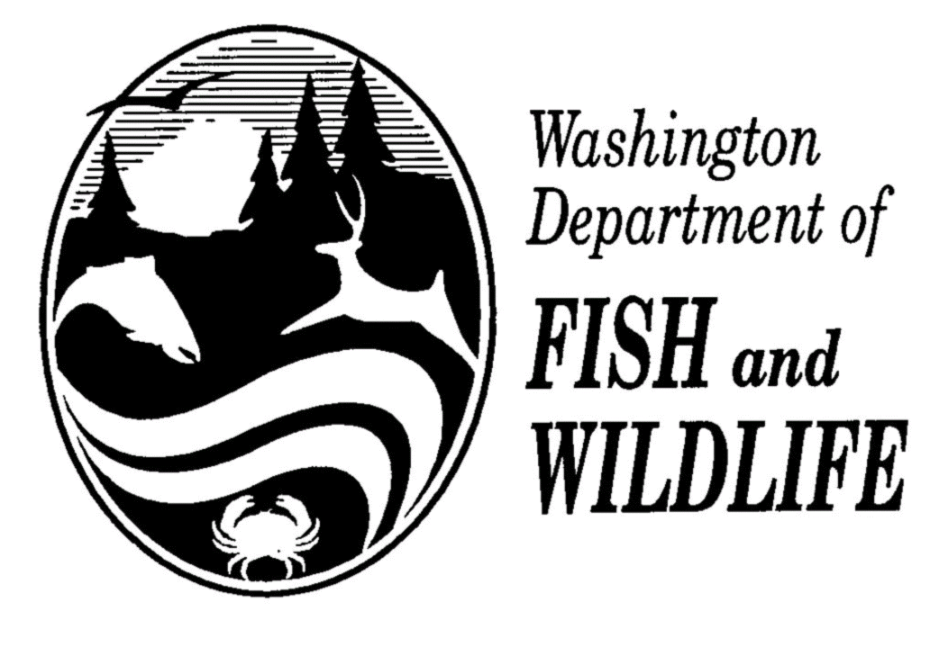 AQUATIC INVASIVE SPECIES DECONTAMINATION REPORT

Contact /Sponsor:________________________________ Date:____________

Water: _________________________________________ Permit#__________

I hereby affirm that the boat, trailer, engine, or water containers I will use during this fishing contest
have been in physical contact with waters outside of Washington State in the last 30 days, and that
I have taken the following steps in accordance with WAC 220-220-220 (7) (a) (i) (ii) (A) (b) to
decontaminate said equipment.

Initials Date Performed

____ Washed hull with hot (140⁰F) water or a 10% _______ ________________
solution of household bleach left on wet for one
(1) hour and then rinsed.

____ Ran the motor with hot (140⁰F) water for 15 _______ _________________
seconds or in a 10% solution of household
bleach for at least (1) minute, let sit wet for
one (1) hour, and then flushed with fresh water.

____ Flushed the bilge, live well, and any other ________ _________________
equipment exposed to water with hot (140⁰F)
water or a 10% solution household bleach, let
sit wet for one (1) hour and then rinsed.

____ Had a complete inspection of boat, trailer, engine ________ ___________________
and water containers by the contest director or
designee for this event.

Boat owner: Print name, address, and phone number.
__________________________________________________________________________________________

__________________________________________________________________________________________

__________________________________________________________________________________________

Boat owner signature:________________________________________________________________________

Contest Director or Designee:__________________________________________________________________

Date:_____________________________________________________________________________________

NOTE to Contest Director: Attach and return this statement with final contest report due within 30 days of contest completion to Bruce Baker – Fish Management/Inland Fish Program.

