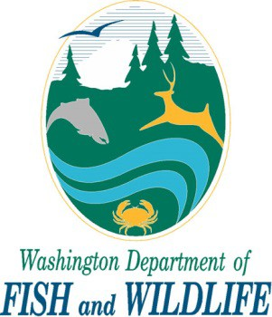
Attachment for Additional Property Owners
AGENCY USE ONLY

Date Received:
APP ID#:

Use this attachment only if you have more than one property owner. Complete one attachment for each additional property owner impacted by the project.

My project occurs on public lands (provide government agency name below only).

Business or Government Agency Name (if applicable)
First Name |  | Middle Name |  | Last Name
Address 1
Address 2
City |  | State |  | Zip
Primary Phone | Ext. |  | Mobile Phone | FAX
( ) |  |  | ( ) | ( )
E-mail
Signature of Property Owner
I consent to Washington Department of Fish and Wildlife staff entering the property where the project is located to inspect the project site or any work related to the project.
Printed Name |  | Signature |  | Date Signed
Mail, hand deliver, FAX, or email this form along with your Simplified Application to:

Washington Department of Fish and Wildlife Habitat Program
PO Box 43234
Olympia, WA 98504-3234
(360) 902-2534
FAX (360) 902-2946
Email: HPAapplications@dfw.wa.gov

