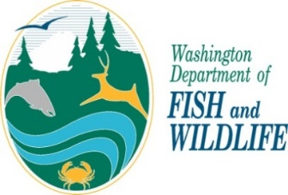 | Personal information provided to the Washington Department of Fish and Wildlife may be disclosed via a public records request. All the information you provide in this application form becomes a public record that may be subject to inspection and copying by members of the public, unless an exemption in law exists. The Department’s policy regarding Privacy Protection and Public Disclosure Requests is available upon request.
Falconry Permit Renewal Application

WA State ID #: Name:

Current Permit Class: Permit Expiration Date:

Date of Birth: (Falconers under 18 years old must have a Parent or Guardian’s signature)

Hair: Eyes: Height: Weight:

Apprentices – Who is your Sponsor:

General and Master Falconers – Do you currently sponsor any Apprentices? Yes No

If yes, please name your Apprentices:

Two-Year General and Master Falconers – Are you willing to be listed as a Sponsor? Yes No

Contact and Facility Information

Home Phone: Work Phone: Cell Phone:

Email:

MAILING ADDRESS: City: Zip Code: County:

FACILITY ADDRESS: City: Zip Code: County:

HOME ADDRESS: City: Zip Code: County:

Have any of these addresses changed within the last two years? Yes No
Has your email address changed within the last two years? Yes No
How many birds do you currently possess on your Falconry Permit?
What species of raptors do you currently possess on your Falconry Permit?
Do you currently hold any USFWS Migratory Bird Propagation, Abatement, or Rehabilitation Permit? Yes No

If yes, please list permit names and numbers:

APPLICANT’S CERTIFICATION AND SIGNATURE
I certify that I have read and am familiar with the Washington Department of Fish and Wildlife’s falconry and hunting regulations and the U.S. Fish and Wildlife Service falconry regulations, and the federal Migratory Bird Treaty Act, and that the information I have submitted is complete and accurate to the best of my knowledge and belief. I understand that any false statement herein may subject me to cancellation of the application, revocation of my falconry permit, and/or criminal penalties.

Applicant’s Signature Date

If you are an APPRENTICE, your sponsor must sign this application

Sponsor’s Signature Date

If you are less than 18 years of age a Parent or Guardian must sign this application:

Parent or Guardian’s signature Date

Please return completed application to: Falconry Manager, WDFW, 16018 Mill Creek Blvd., Mill Creek, WA 98012

