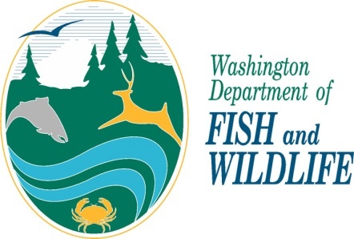 | Personal information provided to the Washington Department of Fish and Wildlife may be disclosed via a public records request.  All the information you provide in this application form becomes a public record that may be subject to inspection and copying by members of the public, unless an exemption in law exists. The Department’s policy regarding Privacy Protection and Public Disclosure Requests is available upon request.  Please allow 30 days for processing of this application.

Falconry Permit Upgrade Application

Name: Male Female

Date of Birth: WA Falconry Permit #:

Contact and Facility Information

Home Phone: Work Phone: Cell Phone:

Email:

MAILING ADDRESS: City: Zip Code: County:

FACILITY ADDRESS: City: Zip Code: County:

HOME ADDRESS: City: Zip Code: County:

Upgrade Apprentice to General Falconry Permit
1. List the raptor(s) you have held in the past two or more calendar years and dates you have possessed each.
Species | Dates held | How Acquired | Disposition if not in possession

2. List the raptor(s) currently in your possession.
Species | Date Acquired

3. Describe in detail your falconry activities explaining your falconry experience and methods for maintaining, training, flying, and hunting your raptor(s) as an Apprentice Falconer:

4. List the species (common name) of quarry you have successfully taken with your raptor(s) and which raptors took that quarry and in what year.
Do you have a Wild ID #? If Yes, what is your number:
Quarry | Which raptor | Year(s)

5. SPONSOR’S acknowledgement of experience and readiness for Apprentice’s upgrade to General Falconer:
Do you confirm and agree with your Apprentice’s above claims and statements? Yes No
Please estimate your time with your Apprentice, i.e. how many hours/week or days/month did you spend with your Apprentice teaching and practicing falconry:

Sponsor Certification
____________________________________ (name of applicant) has practiced falconry at the apprentice falconer level or equivalent for at least two years including maintaining, training, flying, and hunting the raptor(s) for at least four months in each year. I have personal knowledge of, and witnessed the practice and abilities of, the above applicant. I believe this applicant is qualified to attain General Falconer status and hereby recommend this person for a General Falconry Permit.”
I certify that the information submitted on this application by the applicant is complete and accurate to the best of my knowledge and belief.
Signature of Sponsor |  | Date
Person signing application, please print your:

Name
Mailing Address
Phone Number | Email

Please check if you are this applicant’s original sponsor:
If not the original sponsor, how long have you been this applicant’s sponsor?

6. Applicant Certification for Upgrade to General:
I certify that the information I have submitted is complete and accurate to the best of my knowledge and belief. I understand that any false statement herein may subject me to cancellation of the application and /or criminal penalties.
Applicant’s Signature |  | Date
Signature of Parent or Guardian (if applicant is under 18 years of age) |  | Date
Upgrade General to Master Falconry Permit
1. Describe your experience practicing falconry at a General Falconer level with your own raptor(s) and include years in which these activities occurred:

2. Please list the raptors you have possessed during your time as a General falconer and the dates (months and years) these raptors were held:
Species | Dates held | Disposition if not in possession
3. List the raptor(s) currently in your possession.
Species | Date Acquired

4. Please list the kind of quarry (common name) you have successfully taken with your raptor(s) and which raptors took that quarry and in what year.
Quarry | Which raptor

5. Describe any other pertinent experience and qualifications:

6. Applicant Certification for Upgrade to Master:
I certify that the information I have submitted is complete and accurate to the best of my knowledge and belief. I understand that any false statement herein may subject me to cancellation of the application and /or criminal penalties.
Applicant’s Signature |  | Date

Please return Application to:
WDFW
Falconry Manager
16018 Mill Creek Blvd
Mill Creek, WA 98012

Revised 6/2019

