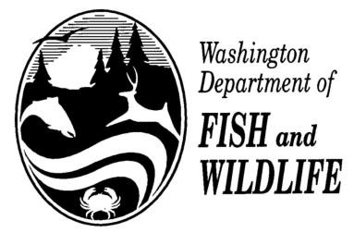AQUATIC INVASIVE SPECIES DECONTAMINATION REPORT

Contact /Sponsor:_ Date:_ Water: Permit#

I hereby affirm that the boat, trailer, engine, or water containers I will use during this fishing contest have been in physical contact with waters outside of Washington State in the last 30 days, and that
I have taken the following steps in accordance with WAC 220-220-220 (7) (a) (i) (ii) (A) (b) to decontaminate said equipment.

Initials Date Performed

Washed hull with hot (1400F) water or a 10% solution of household bleach left on wet for one
(1) hour and then rinsed.

____ Flushed the motor with hot (1200F) water for 5
minutes.

Flushed the bilge, live well, and any other equipment exposed to water with hot (1400F) water or a 10% solution household bleach, let sit wet for one (1) hour and then rinsed.

Had a complete inspection of boat, trailer, engine and water containers by the contest director or
designee for this event.

Boat owner: Print name, address, and phone number.

Boat owner signature:

Contest Director or Designee:

Date:

NOTE to Contest Director: Attach and return this statement with final contest report due within 30 days of contest completion to Bruce Baker – Fish Management/Inland Fish Program.

