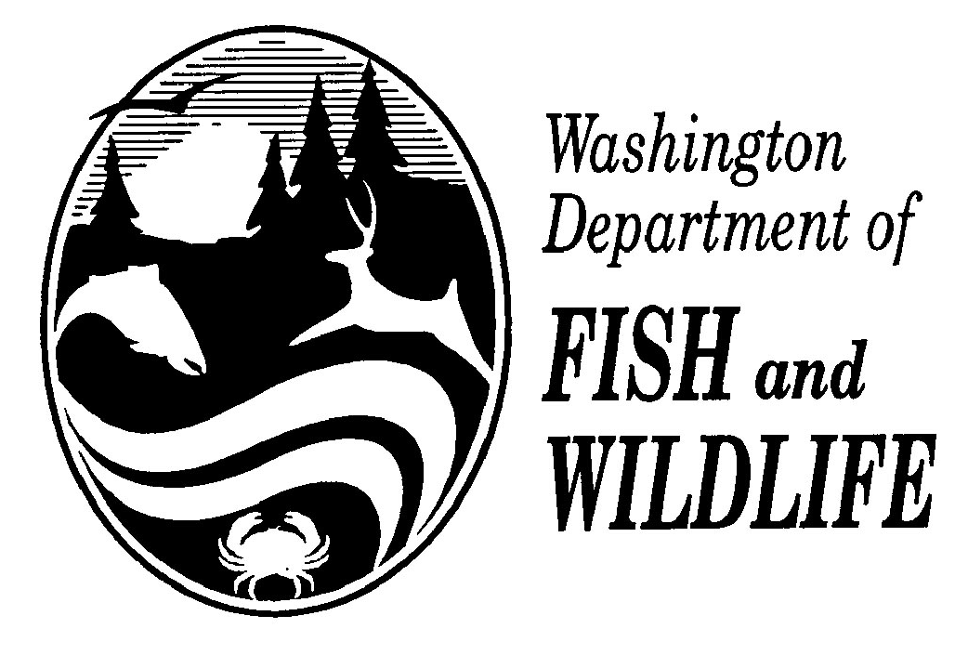
AQUATIC INVASIVE SPECIES DECONTAMINATION STATEMENT
(To be completed by contest participants using boats only)

Contact/Sponsor:_______________________________________________ Date:____________

Water: _______________________________________________________ Permit#__________

Has your boat, trailer, engine, or any water containers that you will use during this fishing contest been in physical contact with any waters outside of Washington State in the last 30 days?

 | Print Full Name | Home Location  City / State | Check |  | Phone # | Signature | Date
 |  |  | Y¹ | N
1
2
3
4
5
6
7
8
9
10
¹ If yes, you must complete a decontamination report prior to participating in this fishing contest.

I hereby certify that the following individuals are known to me and have provided correct information to the best of my knowledge.

Contest Director or Designee:_________________________________________________________ Date:_____________________

NOTE to Contest Director: Attach and return this statement with final contest report due within 30 days of contest completion to Bruce Baker – Fish Management/Inland Fish Program.

