DocuSign Instructions for Completing the
Commercial Whale Watching License Applications
- From https://wdfw.wa.gov/licenses/commercial/whale-watching#purchase select the link for the application you wish to submit. The link will present a form within DocuSign.
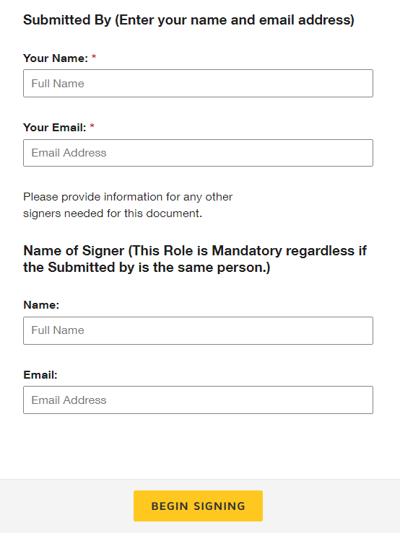
- In the Submitted By section, enter the name and email address of the person filling out the application information.
- In the Name of Signer section, enter the name and email address of the person signing the application. (You must enter the name and email address of the application Signer to receive the email to attest to the accuracy of the information provided and sign the application.)
  - The business owner must sign the Commercial Whale Watching Business License Application. Licenses will be issued to the business owner with up to four vessels listed on one license. If there are more than four vessels, an additional license will be issued showing these additional vessels.
  - The operator must sign the Commercial Whale Watching Operator License Application. Licenses will be issued to the individual operator.
  - The kayak guide must sign the Commercial Whale Watching Kayak Guide License Application. Licenses will be issued to the individual kayak guide.
- Select the Begin Signing button.

- This will take you to the application form. Press Continue, and then select the Start button to begin the entering the application information. DocuSign will guide you through the required fields on the application.

- When all the information has been entered, select the Finish button. This action will send an email to the applicant. At this point, you can close the form, but the application is not yet complete.

- You must open the email and follow the Review Documents prompt to complete the license attestation and sign the application. The link will take you back into the form to complete the last page. Again, press Continue and Start to finish the attestation and signature portions of the form. Then, select Finish. This submits your completed application.

- Once the application has been signed, WDFW Commercial Licensing staff will be notified that the application is awaiting review.
- During the application review period, print the signature page to confirm you have submitted your application to present to an enforcement officer upon request. You can print from either:
  - The Review Document button in the email, OR
  - At the end of the signing process when a download option is presented by DocuSign.

- Upon approval, you will receive an email from DocuSign with your license attached.

- Print the License page.

- If the license is Business License, print a copy for each vessel listed on the license.

- If the license is either Operator License or Kayak Guide License, print a copy and keep on your person while engaging in commercial whale watching activities.

