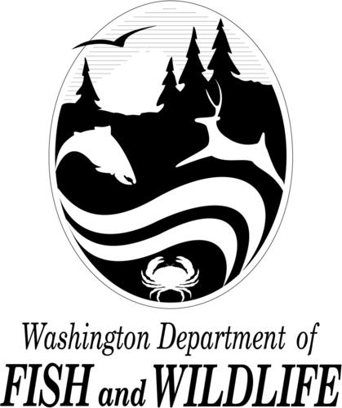
ALEA Volunteer Cooperative Grant Program
Send completed report to:

Joshua.nicholas@dfw.wa.gov
or
WDFW
ATTN JOSH NICHOLAS
PO BOX 43150
OLYMPIA WA 98504-3150

Quarterly Report Form

Use “Tab” key to navigate form fields.

Project Contact Information
Your Contract #:  - | Project Title:
Project Status
Not started yet. What is the anticipated start date?

Project has been started

Project has been completed.

Project progress (note: you have more room than shown below - this section will expand as you type)
Describe your progress on the performance measures listed in your grant proposal and any other project objectives.

Are there any issues we should be aware of that may prevent your project from being successful?

Yes (describe below) No

Volunteer Hours
How many volunteer hours were documented during the past quarter?
How many volunteer hours have been documented since the beginning of your grant period (7/1/21)?

Report Approval
Grantee Representative:  Name: Date: |  | ALEA Program Manager:  Name: Josh Nicholas Date:

