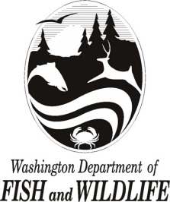

STATE OF WASHINGTON

Washington Department of Fish and Wildlife (WDFW)

SOLE SOURCE POSTING

1) A description of the purpose and scope of the contract: The Washington Department of Fish and Wildlife (WDFW) contemplates awarding a sole source contract to AXYS Analytical Services to assist WDFW in the continued chemical analysis of various fish and invertebrate tissues in support of WDFW’s long term toxics monitoring program on an optional use/as needed basis.
2) The criteria or rationale justifying the sole source contract: AXYS Analytical Services has been performing this work for WDFW since 2016. AXYS Analytical Services holds the historical data necessary to continue this long-term work. They can provide the service seamlessly. The costs are based on the test being requested for each tissue sample and bills per their cost sheet. There will be no learning curve costs and they already have the necessary personnel and tools to continue this project.
3) The name of the prospective contractor: AXYS Analytical Services (Sidney, BC, Canada).
4) The period of performance: anticipated to start February 10, 2023 (or as soon as approved by Washington State Department of Enterprise Services), through December 31, 2028.
5) The projected contract value: $2,400,000 (approximately $400,000/year)
6) Options for extensions: extensions will not be required.
7) A description of the process for providing vendor inquiries or responses to the posting agency, including timelines and requirements and a request for capability statements if a vendor believes they can provide the goods or services being procured under the sole source contract: Offerors contemplating the above requirements are required to submit a capability statement detailing their ability to meet the state’s requirements by 12:00 p.m. PST on February 2, 2023. To submit capability statements or for questions, please contact: Theresa Walker, Deputy Contracts Officer, at Theresa.Walker@dfw.wa.gov

