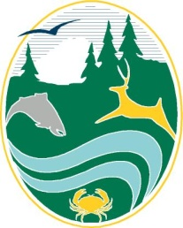 | Washington Department of Fish and Wildlife Wildlife Director Decision

March 27, 2023
Agenda
Via Zoom Webinar

Monday, March 27, 2023 – Director Meetings

1:00 PM | 2023 Wildlife Season Setting Briefing and Public hearing- Anis Aoude, Ottie Holcomb, Kyle Spragens, and Kyle Garrison  Location: Zoom Link (https://us06web.zoom.us/j/82106643920)  Join by telephone: 1-253-205-0468 or 888 475 4499 (Toll Free) Webinar ID: 821 0664 3920  Agenda topics:  - Migratory Waterfowl  - Deer  - Elk  - Bighorn Sheep, Moose, and Mountain Goat  - Landowner Hunting Permits (LHP)  Public Comment  - Registrants will be called upon in the order of their time stamped registration. You will have three minutes to speak unless the Hearings Officer sets a lesser time at the onset of the agenda item.
Information on how to register:

If you are interested in providing verbal public comment, please register here. The following registration deadlines are in effect:
- Registration for public comment closes at 8 am on Sunday, March 26, 2023.
- All information entered on the form is subject to public disclosure.

