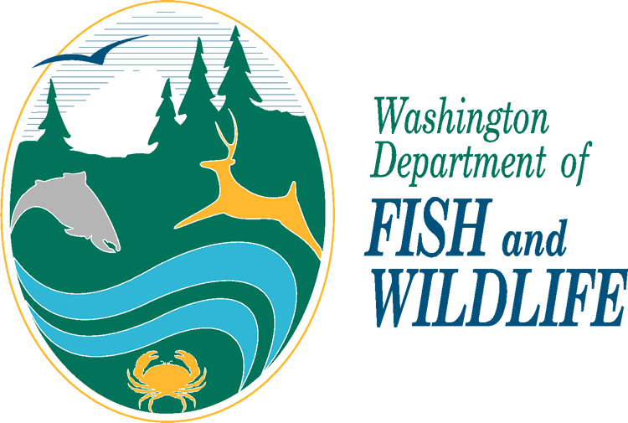
SHELLFISH IMPORT PERMIT
APPLICATION FORM

Please refer to the WDFW Shellfish Import Approval Requirements for Shellfish Aquaculture (separate document) for completing this application. This form is required and must be completed electronically or legibly by hand. Incomplete applications will be returned and result in delay in the issuance of your permit.

E-mail, mail, or fax applications and applicable attachments to:
shellfishpermits@dfw.wa.gov
Washington Department of Fish and Wildlife
375 Hudson Street
Port Townsend, WA 98368
PHONE (360) 316-6898
FAX (360) 302-3031

SECTION A: APPLICANT INFORMATION

Company/Organization name:

Applicant Name:

Physical Address:
City, State, Zip:

Telephone:

E-mail:

Mailing Address:

SECTION B: RENEWAL (please skip this section if not renewing a previous permit)

1. Is this application is for the renewal of a previous permit? Yes No

If yes, please provide previous permit #:

2. Requesting changes to the previous permit? Yes No

If yes, please complete all following sections. If no, please skip to section G.

SECTION C: IMPORT INFORMATION

1. Purpose of import: Commercial aquaculture Non-commercial Research Display
Other, please specify:

Specific information on purpose of import:

2. Species Proposed for import (common and/or scientific name):

If more space is needed, please attach a separate species list with this form.

3. Life stage and quantity proposed for transfer; list all:

If more space is needed, please attached a separate species list with this form.

4. SOURCE location(s) or facility(ies) of proposed import (specific water body, state, country):

5. DESTINATION location(s) or facility(ies) to which applicant desires to transfer imported animals. Please indicate off-loading area(s) if different from final destination. Select location type, list the general area (Coast, Strait, North/Central/South Puget Sound, Hood Canal, Admiralty Inlet, San Juan Islands...etc.) and the specific location (tax parcel #- preferred, but not required). Please note that in some cases, further information from the applicant may be required.

Tidelands Nursery (FLUPSY) Hatchery Wet Storage Processing facility
Terminal quarantine facility* Other

Please provide general and specific location address(es), parcel number(s), or Lat/Long(s)

6. If receiving body is a facility (e.g. hatchery, nursery, research lab, educational institution, aquarium, etc.), has this facility previously been inspected and approved by WDFW? Yes No

7. Attach or describe other information relevant to proposed import such as all responsible individuals involved with the import, special holding conditions, schematics and protocols of holding facilities, prior record of approved importations, etc. Please note that all facilities shipping to WA must have a facility biosecurity plan on file with WDFW.

8. List other authorized personnel to be included on the permit, if any:

SECTION D: HEALTH HISTORY AND CERTIFICATION

1. Attach or describe the shellfish health history (including any known risk) for the geographic source location. This may include government reports and documents, literature, shellfish health examinations by pathologist, and other credible documents (if applicable):

2. Attach to permit application the shellfish disease free certifications, by a WDFW approved pathologist, which are representative of stocks proposed for import (if applicable). Please refer to the shellfish import guidelines and requirements document for details on specific testing requirements.

Imports for Aquaculture purposes: WDFW import requirements can be viewed at https://wdfw.wa.gov/licenses/fishing/shellfish-import-transfer#imports.

If this is an import into a *terminal quarantine facility, facility must be WDFW-approved and application must be accompanied by a facility biosecurity plan, site plan, photos, and research plan.

SECTION E: AQUATIC FARM REGISTRATION

1. Will this proposed import be used to create a new (previously non-existing) cultivated shellfish bed?

Yes No

2. If your answer is “yes”, you must have an approved Aquatic Farm Registration (AFR) and that number must accompany this application.

AFR Number of Newly Cultivated Beds:

SECTION F: Legal Disclaimer, Shellfish Implementation Plan

Important! For purposes of this application, shellfish cultivation involves the “culture of aquatic products” and generally includes active efforts to cultivate shellfish via planting and/or other activities like gravelling or gear maintenance to enhance the productivity of any area whether or not it includes some natural set of shellfish. Be advised that if you are establishing a new shellfish cultivation bed there is a separate duty to comply with the Shellfish Implementation Plan (SIP), entered as a court order in United States vs. Washington, in order to ensure that shell-fishing rights of Puget Sound Treaty Tribes are given due consideration. Section 6 of the SIP requires commercial shellfish growers to provide affected tribes with certain advance notices prior to establishing new cultivation beds and provides processes for growers and tribes to work together to develop any required management plans for shared harvest. Further, this application may be subject to a tribal review period of up to 20 working days prior to permit being issued.

RCW 77.60.080, RCW 77.60.060, WAC 220-340-150, WAC220-340-050, and WAC 220-370-200 require all transfers and imports be accompanied by a permit issued by the Director of Fish and Wildlife or his agent.

*As defined in WAC 220-370-050(21) "Terminal quarantine facility" is defined as a department-approved quarantine facility where imported aquatic invertebrates are held for public display or research purposes only, with minimal risk that the organisms will be released or that untreated quarantine facility holding waters will commingle with state waters. The operation plan of the quarantine facility must be approved by the department prior to the introduction of any organisms. At the conclusion of the public display or research, the organisms held in quarantine shall be destroyed and all waters and waste disinfected and disposed of using methods approved by the department.

SECTION G: ACCEPTANCE AND SIGNATURE

By checking this box, the permittee certifies that the provided information is accurate and complete, and agrees to abide by the conditions set forth in any Shellfish Import Permit issued by the Washington Department of Fish and Wildlife. The permittee acknowledges that they have read and understand the requirements outlined in the WDFW Shellfish Import Approval Requirements for Shellfish Aquaculture (separate document).

Name:

Date:

