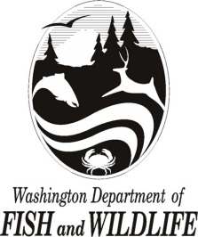

STATE OF WASHINGTON

Washington Department of Fish and Wildlife (WDFW)

SOLE SOURCE POSTING

1) A description of the purpose and scope of the contract: The Washington Department of Fish and Wildlife (WDFW) contemplates awarding a sole source contract to ACTEA to provide WDFW with proprietary specialized data set and license for ROMS resolution Climate Projections for Washington State waters.
2) The criteria or rationale justifying the sole source contract: ACTEA created the historical proprietary data necessary to provide the data sets WDFW needs specific to Washington waters. The costs are based on set pricing for their data which can be found at their website (ACTEA.EARTH).
3) The name of the prospective contractor: ACTEA (San Francisco, California).
4) The period of performance: anticipated to start June 5, 2023 (or as soon as approved by Washington State Department of Enterprise Services), through June 30, 2023.
5) The projected contract value: $45,000 fixed price
6) Options for extensions: extensions will not be required.
7) A description of the process for providing vendor inquiries or responses to the posting agency, including timelines and requirements and a request for capability statements if a vendor believes they can provide the goods or services being procured under the sole source contract: Offerors contemplating the above requirements are required to submit a capability statement detailing their ability to meet the state’s requirements by 12:00 p.m. PST on May 26, 2023. To submit capability statements or for questions, please contact: Theresa Walker, Deputy Contracts Officer, at Theresa.Walker@dfw.wa.gov

