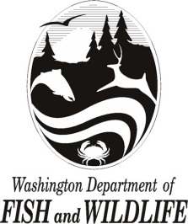

STATE OF WASHINGTON

Washington Department of Fish and Wildlife

SOLE SOURCE POSTING
May 17, 2024

The Washington Department of Fish and Wildlife (WDFW) contemplates awarding a sole source contract to EVERYWHERE Communications, Inc. to centrally manage all Garmin GPS satellite communication devices under an enterprise-wide solution to meet WDFW’s emergency field communications requirements.
WDFW will enter into a two (2) year contract with EVERYWHERE Communications Inc. on or about June 3, 2024 and will continue for an initial twenty-five (25) month term, with the option to extend for two (2) additional years. The estimated cost of the two-year contract is $650,000.
Offerors contemplating the above requirements are required to submit capability statements detailing their ability to meet the state’s requirements:
- Provide a commercial off-the-self solution for enterprise management of up to 800 Garmin GPS devices that allows WDFW to centrally manage GPS devices through the contractor’s web portal in order to ensure the emergency notification system is operating appropriately and that all devices are enrolled in satellite plans.
- Provide Irridium satellite communication service for all WDFW owned Garmin GPS devices.
- Provide a solution that allows WDFW to standardize additional WDFW contacts in case of emergencies beyond the two allowed by Garmin’s GPS device application, and allows for unlimited emergency contacts for SOS one way communication.
- Automatically loads Garmin GPS devices being purchased into the Garmin GPS device application and have an active satellite service subscription prior to the WDFW user receiving the device.

- Provide online training resources and consultation to ensure WDFW staff are trained to operation Garmin equipment and the contractor’s solution.

Submit capability statements by noon local Olympia WA time on May 27, 2024. To submit capability statements or for questions, please contact: Jeff Hugdahl, Contracts and Purchasing, at jeffrey.hugdahl@dshs.wa.gov.

