Small Project Internal Scoping Request and CE Tracking Form
Wenatchee River Ranger District

STEP 1. Project Description and MAP
Open blank tracking form and save under different name in O:\NFS\OkanoganWenatchee\Project\WNR\SmallProjects2012
Pages 1 and 2 to be completed by project leader/sponsor and filed in O-drive. SAVE your edits. Notify Assigned Specialists when form is ready for review, providing document name and pathway. All specialists then access form on the O-drive, and record progress of review and findings on pages 3 and 4. SAVE your edits.
TIPS: Write only in white spaces, using as many lines as needed (lines will expand and wrap). SAVE OFTEN -- during and after every edit session.
Use SmallProject2012 folder on T-Drive for supporting GIS work.
Request By |  |  |  |  |  |  |  |  |  |  |  |  |  |  |  |  |  | Date of Request |  |  |  |  |  |  |  |  |  | Project Timeline Date  Response Needed by:  Decision by:  Project Implementation Date:  Job Code if over 2 hours
Project Name |  |  |  |  |  |  | Mission Ridge Expansion Area Temporary Road
Project Location  (T., R., Sec, 1/4) |  |  |  |  |  |  | T21N, R20E, Section 24 |  |  |  |  |  |  |  |  |  |  |  | HUC5 Watershed Name/No. |  |  |  | Lake Entiat-Columbia River 1702001003 |  |  |  |  |  |  |  |  |  |  | Elevation (ft) |  |  |  |  | 3,100 to 4,100
Type of Project (check all that apply)
Veg Mgmt |  |  | Special Use Event |  |  |  | Other Special Use Permit |  |  | Mining |  |  | Special Forest Product |  |  | Danger Tree Mgmt |  | Facilities Maintenance |  |  | Road Maintenance |  |  |  | Trail Maintenance |  |  |  | Trail Reloc |  |  | Hazardous Fuels Abate |  |  |  | Habitat Improvement |  | Describe
 |  |  |  |  |  |  | x |  |  |  |  |  |  |  |  |  |  |  |  |  |  |  |  |  |  |  |  |  |  |  |  |  |  |  |  |  |  | Geotechnical study
NWFP Allocation (Acres in each that apply) |  |  |  |  |  |  |  |  |  |  |  |  |  |  |  |  | 1990 Wenatchee LRMP (Acres in each that apply)
LSR | MLSA |  |  |  | Matrix |  |  | Riparian Reserve |  |  | Wilderness |  |  | Admin  w/drawn |  |  | GF |  | OG1 | OG2 |  | EW  1, 2, 3 |  | ST1 |  | ST2 |  | RE  1, 2, 3, 4 |  |  | RN1 |  | SI  1, 2 |  | WS  1, 2 |  | WI 1 |  |  | UC-1 | RMA
 |  |  |  |  |  |  |  | 0.4 |  |  |  |  |  | 1 |  |  |  |  |  |  |  |  |  |  |  |  |  | 1
Other Designations (check all that apply. See “Reference Maps” subfolder in O:\NFS\OkanoganWenatchee\Project\WNR\SmallProjects2012
(IRA = Inventoried Roadless Area; PWU = potential wilderness area; PARW = preliminarily administratively recommended wilderness; CH = Critical Habitat, RNA = Research Natural Area)
IRA |  | PWA |  |  |  | PARW |  |  | unroaded area > 5000 ac |  |  | WSA |  |  | Wild and Scenic River |  |  | Key Watershed |  |  |  | Goshawk or Eagle Nest |  |  | NSO CH |  | Bull Trout CH |  |  | RNA |  |  | Any other “flags” for internal reviewers

Proposed Action: (who, what, when, how, where, duration of activity or disturbance, acres treated, miles of trail or road involved, # trees to be removed, prescription, use of heavy equipment,/chainsaws,/generators/explosives/aircraft, use of roads or trails, use of closed roads, use of staging areas, need for hazard tree mgt, does activity entail camping, etc... Details will speed the review process.)
The purpose of this proposal is to construct a temporary road across USFS land (Section 24) to the proposed Mission Ridge Expansion Area (Section 19). See Figure 1 for project loction. Temporary road construction would be completed by Mission Ridge Inc. The temporary road will provide access to conduct a geologic site assessment and determine the feasibility of a future access road from the existing Mission Ridge Base Area to the proposed Mission Ridge Expansion Project which will be developed on private land, purchased in 2014 (Figure 1). Detailed evaluation of the geologic units and associated risks of geologic hazards will require some degree of surface and subsurface exploration. Exploration techniques at the site may include exploratory test-pits, borings, and/or geophysical surveys such as seismic refraction. The temporary road will allow access for subsurface exploration equipment, as well as provide a surface area for possible performance of geophysical surveys. Additionally, the limited upslope cuts of the temporary road may expose the near surface geologic units sufficiently enough to require only minimal additional exploration and inspection. At this time, the precise number, locations and methods for necessary points of exploration cannot be determined for certain until a temporary road is constructed and observed/documented.

In addition to providing access for a geologic survey along and within the path of the proposed expansion area access road, the temporary road would provide access to the private parcel in Section 19 which would allow Mission Ridge and other regulatory and permitting agency personnel to access the site to collect information and gather data relative to design and mitigation of the proposed Mission Ridge Expansion Project. Typically, two to ten people would be on-site working at any one time. This use would be on average less than one time per week. Use of this road would be limited to dry or frozen conditions to minimize rutting and compaction.

Public access would not be allowed on the temporary road. To block access, a gate would be installed at the junction with the existing Mission Ridge parking lot. The road would be designed to meet USFS standards for short-term use. The geologic site assessment would be conducted in accordance with Chapter 11.86 of Chelan County Code.

The major components of the temporary road project are comprised of the following:
1) New special use permit for USFS land
2) Temporary road footprint:
a. approximate length up to 0.67 miles
b. approximate width of temporary road surface up to but not exceeding 16 feet
c. approximate ground disturbance not exceeding 1-acre
d. two temporary bridges placed on temporary supports (above ordinary high water)
3) Assessment of geologic risk and feasibility of an expansion area road
4) Soil erosion control and rehabilitation

Temporary Road Construction
The temporary road would be constructed to provide access to conduct a geologic site assessment. The road would not be open to public use. A gate would be installed at the junction with the existing Mission Ridge Base Area parking lot. The road would be designed to meet USFS standards for short-term use. The temporary road would be a bladed lane pushed across the USFS land and into the Mission Ridge Expansion private parcel. Use of this road would be limited to dry or frozen conditions to minimize rutting and compaction. Soil would be moved by an excavator accessing the project area from the Mission Ridge Base Area parking lot and activity would be monitored by an approved Archaeologist. The site has been surveyed for cultural resources and none were found.

A trackhoe would be used to clear and grade a maximum 16 foot wide temporary road surface for a small tracked drill rig. Ground disturbance would remain under 1-acre.

Trees greater than 8 inches diameter at breast height (DBH) would not be removed, however some trees less than eight inches DBH and shrubs may need to be cleared. The temporary road will fall within the proposed expansion area road corridor width of 32 feet and length of 0.67 miles. This would allow the trackhoe to avoid larger trees and minimize vegetation removal to the extent practicable while minimizing the final length of the road.

The temporary road would require two stream crossings, one at each end of the route (Figure 2). Temporary bridges set on temporary supports above the ordinary high water mark (OHWM) would be used at both crossings. Both temporary bridges would be designed with hydraulic capacity to pass the 100-year flood event and associated debris flow.

The creeks are both small non-fish bearing perennial streams. The creeks range from approximately 2 feet to 5 feet in width and less than 1 foot to 2 feet in depth at the expected areas of both crossings. The riparian vegetation adjacent to the creek on the south end of the route is limited and restricted to a band within 25 to 50 feet of the stream at the point of the crossing. The riparian vegetation adjacent to the creek on the north end of the route is of higher quality and greater abundance and distribution. The number of water crossings would be minimized and constructed with the following parameters:
• Preference to crossing locations where streambed and banks are composed of firm, cohesive soils or rock.
• Approaches to streambanks that have low-percent slopes and short slope lengths.
• In a manner that would disrupt a minimum amount of natural stream channel.
• Crossings that would be constructed as close to a 90-degree angle as possible to the streambed.
• Crossings that would not change the cross-sectional area of the stream channel or natural water flow or degrade water quality or riparian habitat.

Because of the use of temporary bridges at the two crossings, in-water work would not be expected. However, any activity in the water would be restricted to periods of low flow. In-stream work would follow requirements of the Memorandum of Understanding number NFS 17-MU-11062754-049 between USFS and WDFW regarding hydraulic projects on USFS land.

Geologic Site Assessment
For the geologic site assessment, a trackhoe would dig a pit 10 to 14 feet deep to determine subsurface materials and the type of boring drill needed to obtain samples. The drill rig would bore core samples 30 to 40 feet deep. All soils excavated would be replaced once soil sampling is complete. The required number of core samples would be determined in the field during the geologic site assessment.

Soil Erosion Control and Rehabilitation
Temporary road construction would be completed by Mission Ridge Inc. Mission Ridge shall be solely responsible for providing and maintaining facilities to comply with applicable erosion control regulations and to maintain clean access routes. Because roads take soils out of production, effort would be made to keep the length and width of the temporary road to a minimum without sacrificing safety. The greatest potential for soil erosion occurs immediately after construction so disturbed areas would be shaped and stabilized as soon as possible to minimize erosion potential. The temporary road would be rehabilitated by covering with organic material, seeded using a native seed mix approved by the District botanist and drainage features installed as necessary, once it is no longer needed.

Insert electronic map here (“insert as object”, jpeg, suitable for attaching to scoping letter and use in PALS. Display all affected ground, road and trail no’s, streams, contours, TRS, Project Name, legend, scale, and north arrow.
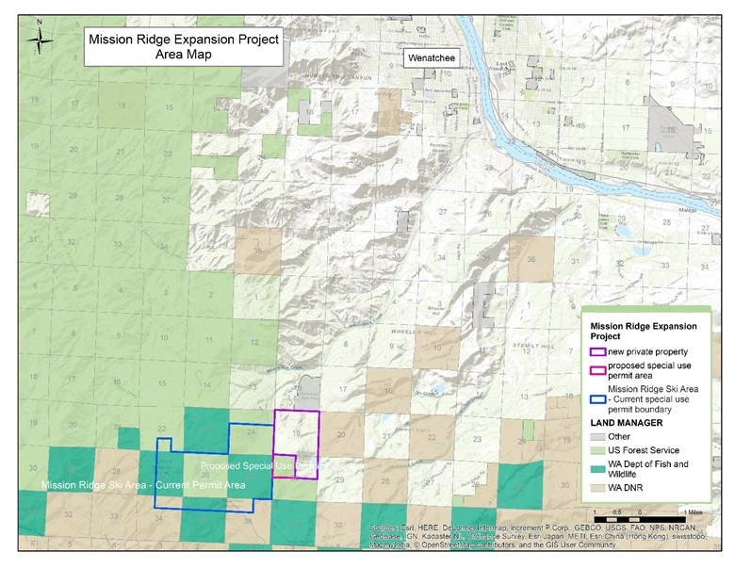
Figure 1. Project location.

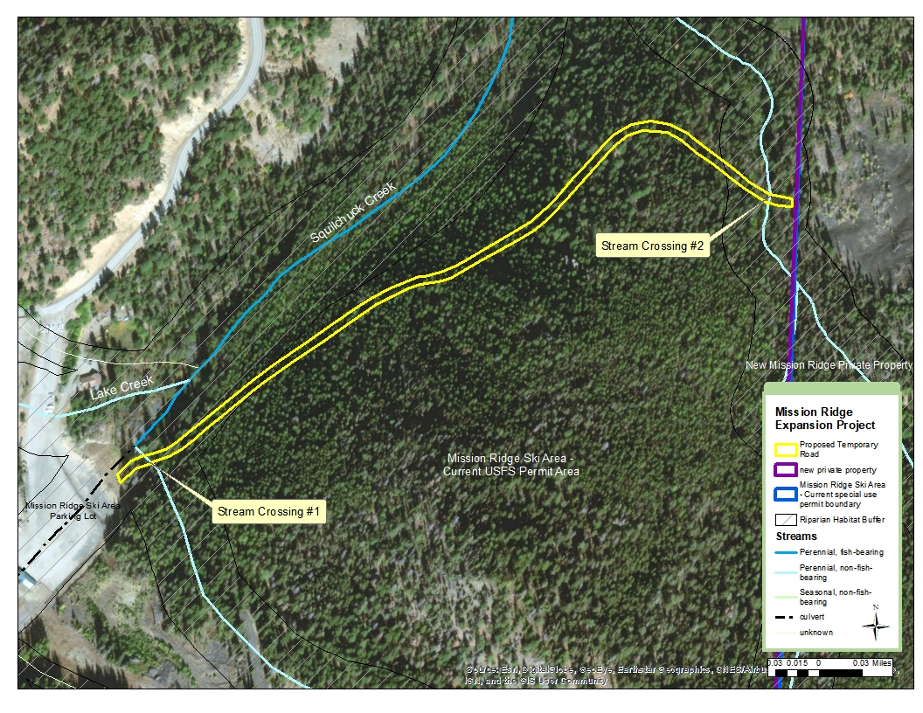
Figure 2. Approximate temporary road route and stream crossing locations.

Step 2 –Specialist Input and Tracks Needed to Support CE / DM / Finding of No Extraordinary Circumstances (To be completed by assigned specialists and/or IDT leader)

Tasks |  |  | Date Completed | Signature | Details
Letters to Tribes (IDTLead) |  |  |  |  | Cultural Resources surveys have been completed for the site and none were found.
Letter to county govt if needed(IDTL)
Date first appearing on SOPA (EC)
Public scoping letter (IDTL)
Public mailing list in project file (IDTL)
Comments received and analyzed (IDTL)
Section 7 Consultation FWS – (Wildlife) |  | Level I complete
 |  | Initiation Letter
 |  | LOC | 10/27/17 | /s/Don Youkey | LOC determination “may affect, not likely to adversely affect” gray wolf, grizzly bear, nothern spotted owl, Canada lynx, AND “no effect” marbled murrelet, North American wolverine, designated critical habitat nothern spotted owl or Canada lynx.
Section 7 Consultation FWS – (Fish) |  | Level I complete |  |  | No ESA listed fish in project area
 |  | Initiation Letter
 |  | LOC | 10/27/18 | /s/ Kathryn McMillan | LOC determination “no effect” ESA listed fish
Section 7 Consultation NMFS-(Fish) |  | Level I complete |  |  | No anadromous ESA listed fish in project area
 |  | Initiation Letter
 |  | LOC | 10/27/18 | /s/ Kathryn McMillan | “No Effect” determination. No LOC required
SHPO – (cultural) |  | Initiation Letter |  |  | Cultural Resources surveys have been completed for the site and none were found.
 |  | LOC
General Resource Reviews  (check reviews needed) |  | Review Complete  (date) | Signature | Findings / Required mitigations  To ensure consistency with laws, FSM direction, policy  (list applicable laws, S&Gs, executive orders, and consistency findings )
Soils
Hydrology |  | 7/30/18 | /s/ Matt Karrer | Project is consistent with the Forest Plan due to temporary bridges outside OHW and capable of passing 100 yr flows, minimizing riparian disturbance during placement of temporary bridges, providing for erosion control during construction and use by such methods as silt fencing, drainage relief, etc., and prompt, effective rehabilitation of temporary road will serve to maintain connectivity, hydrologic, and sediment regimes.
Botany | x | 7/18/2018 | /s/ Lauri Malmquist | No effect on ESA listed plants.
Fish | x | 6/25/18 | /s/ Kathryn McMillan | No effect on listed fish.
Wildlife | x | 6/25/2018 | /s/Don Youkey | The project is consistent with the NFMA and the Forest Plan because it will not contribute to a negative trend in viability of any wildlife Management Indicator Species (MIS). Similarly, the project would be consistent with the 1918 Migratory Bird Treaty Act (MBTA) and the Migratory Bird Executive Order 13186. The project would be consistent regulations covering federally listed species under the ESA, if conservation measures listed below are followed.
Silviculture | x | 12/15/17 |  | Road construction would require some removal of vegetation. The road clearing width would result in a maximum of 1 acre of ground and vegetation disturbance. Stand density varies along the route and will result in some slash and some cut trees (<8inch DBH).  1) Lop and scatter slash by hand in areas where continuous fuel concentrations do not exceed one foot in fuel bed depth.  2) Create slash piles not to exceed 6 by 6 by 6 feet in size where continuous fuel concentrations exceed one foot in depth. Construct piles to have a uniform arrangement perpendicular to the contour of the slope; pile larger vegetation on top to aid in compaction and water dispersion.  3) Place piles outside the drip-line of dominant trees, on the uphill side of those trees, or in areas where the pile would not serve as a ladder fuel. Do not pile higher then 1/3 of the lowest live limbs of the tree’s crown.  4) Burn piles with Forest Service crews directed by the district fuels specialist.
Recreation
Culturals | x | 9/18/17 |  | Cultural Resources surveys have been completed for the site and none were found.
Special Uses | x | 12/15/17 | /s/ kevin smith | Forest Service will issue a short term, 1 year special use permit authorizing the construction of a temporary road and associated geologic risk assessment.
Visuals
Timber
Fire/Fuels | x | 12/15/17 | /s/ Jonathan Tepley | Road construction would require some removal of vegetation. The road clearing width would result in a maximum of 1 acre of ground and vegetation disturbance. Stand density varies along the route and will result in some slash and some cut trees (<8inch DBH).  1) Lop and scatter slash by hand in areas where continuous fuel concentrations do not exceed one foot in fuel bed depth.  2) Create slash piles not to exceed 6 by 6 by 6 feet in size where continuous fuel concentrations exceed one foot in depth. Construct piles to have a uniform arrangement perpendicular to the contour of the slope; pile larger vegetation on top to aid in compaction and water dispersion.  3) Place piles outside the drip-line of dominant trees, on the uphill side of those trees, or in areas where the pile would not serve as a ladder fuel. Do not pile higher then 1/3 of the lowest live limbs of the tree’s crown.  4) Burn piles with Forest Service crews directed by the district fuels specialist.
Roads/Engineering

Resource Conditions:  (Extraordinary Circumstances)  (from 36 CFR 220.6 (b) |  |  | Review Completed  (date) | Signature | Findings
 |  |  |  |  | Species / Habitats / Conditions Present? | Required Mitigations
i. Proposed, Threatened or Endangered species and Critical Habitats | Wildlife |  | 10/27/17 | /s/Don Youkey | The project site is located on a north to northwest facing slope. The terrain is steep with slopes varying from 10 to 90%. Temp road crosses two riparian areas associated with small streams.  Vegetation is primarily closed canopy single story stands dominated by Douglas fir with a mixed conifer component consisting of grand fir, subalpine fir ponderosa pine, lodgepole pine and larch.  Wolverines, gray wolves and grizzly bears are wide-ranging, and could occur in the project area. Small patches of spotted owl habitat are scattered in the vicinity of the project area but not contiguous. | 1) Protect all known listed Threatened, Endangered, and Sensitive species sites, and those discovered prior to or during implementation of project activities.  2) If an active wolf den or rendezvous site is discovered in the vicinity of the project, modify activities to avoid disturbance while being used during the breeding season.  3) Restrict construction activities (road construction/decommission and geotechnical assessment drilling) creating noise above ambient forest conditions, from March 1 to July 31.
 | Fisheries |  | 10/27/17 | /s/ Kathryn McMillan | Two small non-fish bearing perennial streams ranging from approximately 2 feet to 5 feet in width and less than 1 foot to 2 feet in depth at the expected areas of both crossings. The riparian vegetation adjacent to the creek on the south end of the route is limited and restricted to a band within 25 to 50 feet of the stream at the point of the crossing. The riparian vegetation adjacent to the creek on the north end of the route is of higher quality and greater abundance and distribution. | Findings of No Extraoridnary circumstances.  Mission Ridge shall be solely responsible for providing and maintaining necessary erosion control facilities to comply with applicable erosion control regulations and to maintain clean access routes for this action (construction of temporary access road and drilling of test pits).  The number of water crossings would be minimized and constructed with the following parameters:  • Preference to crossing locations where streambed and banks are composed of firm, cohesive soils or rock.  • Approaches to streambanks that have low-percent slopes and short slope lengths.  • In a manner that would disrupt a minimum amount of natural stream channel.  • Crossings that would be constructed as close to a 90-degree angle as possible to the streambed.  • Crossings that would not change the cross-sectional area of the stream channel or natural water flow or degrade water quality or riparian habitat.  Because of the use of temporary bridges at the two crossings, in-water work would not be expected. However, any activity in the water would be restricted to periods of low flow. In-stream work would follow requirements of the Memorandum of Understanding number NFS 17-MU-11062754-049 between USFS and WDFW regarding hydraulic projects on USFS land.
 | Plants |  | 7/18/2018 | /s/ Lauri Malmquist | No ESA listed plant species or critical habitat in project area. | Findings of No Extraordinary circumstances.
Sensitive Spp | Wildlife |  | 6/25/2018 | /s/Don Youkey | Wolverine | *see information above in ESA listed species and designated critical habitat.
 | Fish |  | 6/25/2018 | /s/ Kathryn McMillan | None | *see information above in ESA listed species and designated critical habitat.
 | Plants
Survey and Manage Spp | Wildlife |  | 6/25/2018 | /s/Don Youkey | None known | None
 | Botanical Spp |  | 7/18/18 | /s/ Lauri Malmquist | None | None
MIS and Landbirds | Wildlife |  | 6/25/2018 | /s/Don Youkey | Deer, elk, spotted owls, woodpeckers, and other landbirds | No mitigation required. Project activities could disturb individuals of these species, but would be short term and not lead to a negative trend in viability. It would occur outside the breeding season for all species.
 | Fish |  | 6/25/18 | /s/ Kathryn McMillan | None
ii. Flood plains, wetlands, or municipal watersheds |  |  |  |  | Floodplain associated with two small non-fish bearing perennial streams. The creeks range from approximately 2 feet to 5 feet in width and less than 1 foot to 2 feet in depth at the expected areas of both crossings. The riparian vegetation adjacent to the creek on the south end of the route is limited and restricted to a band within 25 to 50 feet of the stream at the point of the crossing. The riparian vegetation adjacent to the creek on the north end of the route is of higher quality and greater abundance and distribution. | Findings of No Extraordinary circumstances.  Mission Ridge shall be solely responsible for providing and maintaining necessary erosion control facilities to comply with applicable erosion control regulations and to maintain clean access routes for this action (construction of temporary access road and drilling of test pits).
iii. Congessionally designated area (such as wilderness, wild and scenic rivers, etc.)
iv. Inventoried Roadless areas (or wild and scenic study rivers, PWAs, etc.)
v. Research Natural Areas (or Nation. Natural Landmarks, Special Interest Areas, etc., existing or proposed)
vi. American Indian religious or cultural sites or traditional use areas |  |  |  |  |  | In the event that cultural resources or human remains are discovered during project implementation, all activities in the area of the discovery would stop and a Forest Archaeologist would be notified immediately. The area would be reasonably secured and protected during inspection and evaluation by the archaeologist. If the discovery is determined to be a National Register eligible site and avoidance during project implementation is not possible,  site specific mitigation would be developed by the Forest Archaeologist in consultation with the State Historic Preservation Officer (SHPO) and the Tribal Historic Preservation Officers (THPO) for the Confederate Tribes and Bands of the Yakama Nation and the Confederated Tribes of the Colville Reservation. Cultural Resources surveys have been completed for the site and none were found.
vii. Archaeological sites, or historic properties or areas |  |  |  |  |  | *See informaiton above in row vi.

Step 3 – Final NEPA Review (to be completed by District Environmental Coordinator)
Task | Dates / Comments
Analysis Complete and Finding of No Extraordinary Circumstances Verified  (all required mitigations incorporated into Project) | 12/15/17 Decision Memo  No extraordinary circumstances that could potentially result in a significant effect on the environment.
CE Category (see FSH 1909.15 Chapter 30) | 12/15/17 Decision Memo  FSH 1909.15, Chapter 32.12 (8) Approval, modification or continuation of minor, short term special uses of NFS lands , 36 CFR 220.6(d)(8)for the issuance of a special use permit for a term of 1 year.  36 CFR 220.6(e) (8) Short-term (1 year or less) mineral, energy, or geophysical investigations and their incidental support activities that may require cross-country travel by vehicles and equipment, construction of less than 1 mile of low standard road, or use and minor repair of existing road.
DM and Case File Required? YES/NO
NEPA Review of Draft CE/DM
DM signed (date) | 12/15/17
CE / DM uploaded into PALS (date)
Signed DM disseminated to affected / interested persons (IDTL)
Implementation 5 days after DM notification (date)
If a Decision Memo / case file is not required, this scoping record will constitute the analysis file and no further documentation will be required. These projects will not be entered into PALS. For projects requiring DMs: The CE and signed DM (with map attached) will be uploaded into PALS.

